Pega Constellations are the new type of applications introduced by Pega. Now let us see some of them which are newly done in the constellations by creating a new application.

Now while creating new application I would like to have built on application as Cosmos React

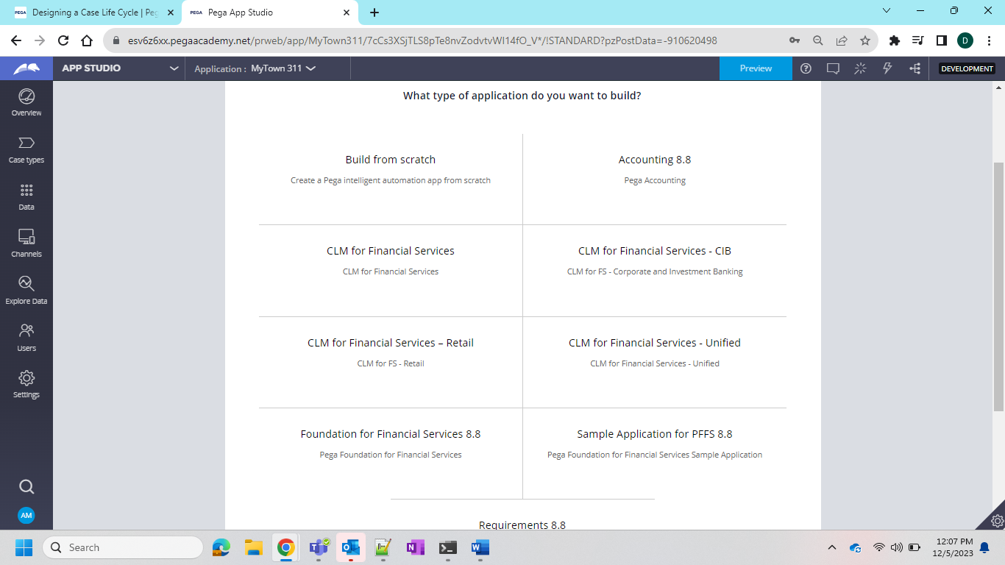

Now after the creation of the application I can see the Access group is already added to me as default now lets directly go on app studio and check

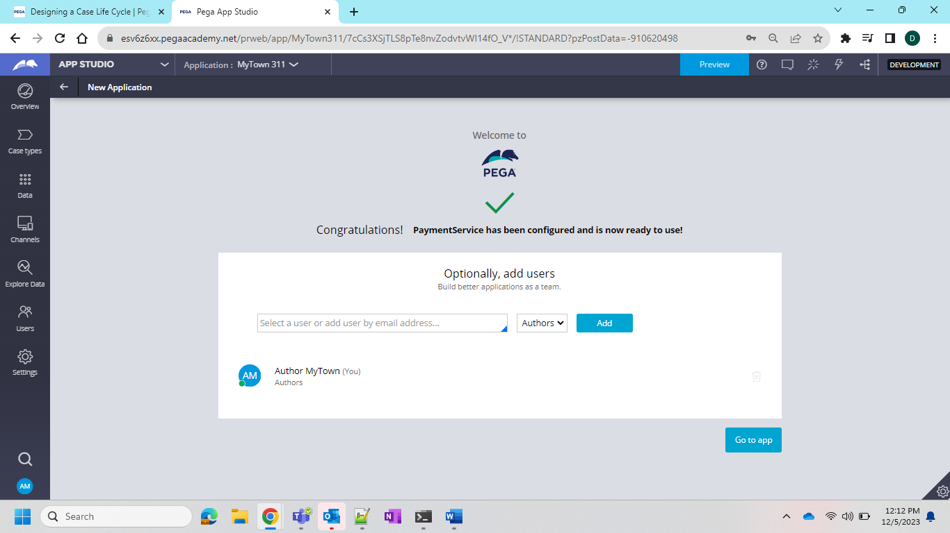

Definition showing built on Application

Now lets create a Casetype and see what happens

And in Case Type we can see one new thing is added that is Remote which means it will create a remote application to which it will connect 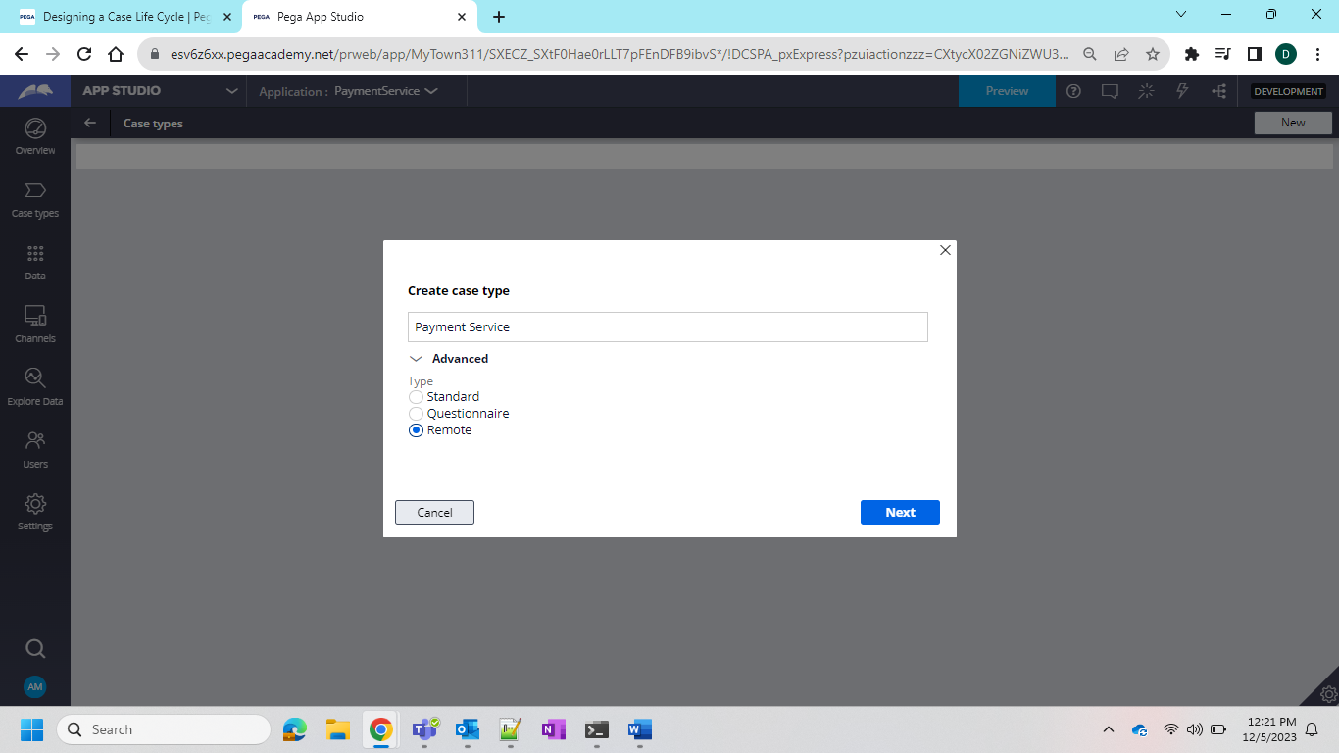

So for now will go with standard

Now in the collect information step we need to add the details and here there are 2 types of the